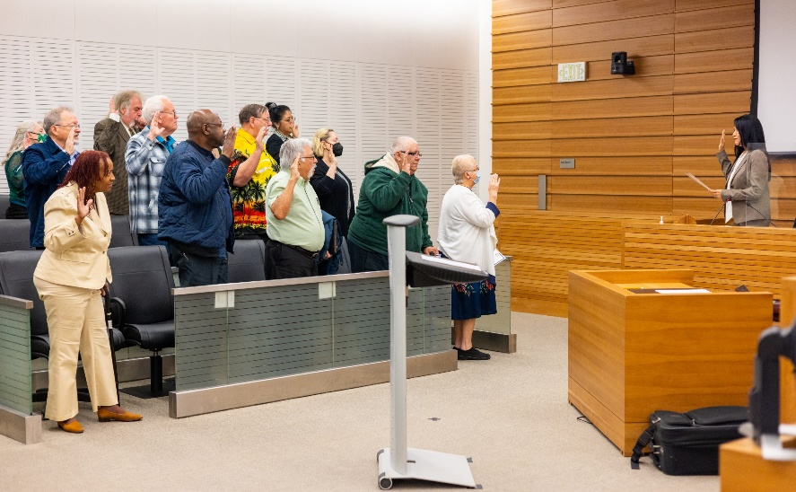

Grand Jury Recruitment Timeline
The San Bernardino County Grand Jury is charged by the California Penal Code to investigate all aspects of county government, including cities and special districts, to ensure the county is being governed honestly and efficiently and that county monies are being handled appropriately.
Application |  | Orientation and Background Check |  | Interview |  | Selection Ceremony

Four Main Components of the Grand Jury Application Process

2025 Grand Jury Selection Ceremony: December 13th, 2024
□ | OPEN NOW | Grand Jury Recruitment is open all year long! Apply online at: http://wp.sbcounty.gov/grandjury/ or call (909) 382-3971 to request an application.
□ | 7/31/2024 | Application Deadline to be considered for 2025 Grand Jury
□ | 8/2024 | Letter will be sent to applicants regarding Mandatory Applicant Orientation
□ | 8/2024 | Mandatory Applicant Orientation and Receive Background Check Information and Voucher
□ | 10/2024 | Pending Background Checks-Interviews will be conducted by Panel of Judges in all 5 Districts
□ | 11/2024 | Candidates will be summoned to Ceremony-30 Grand Jurors will be chosen
□ | 12/13/2024 | 2025 Grand Jury Selection Ceremony-San Bernardino Superior Court-Justice Center/Department S:1
□ | 1/2025 | Deadline for Grand Jury members to apply to be Foreperson
□ | 1/2025 | Foreperson Interviews will be conducted, and Foreperson will be announced
□ | 1/2025 | Mandatory California Grand Jurors Association Training-Virtual
□ | 1/2025 | Mandatory California Grand Jurors Association Foreperson and Pro Tem Training Workshop-Virtual
□ | 3/2025 | Mandatory California Grand Jurors Association Report Writing Workshop-Rancho Virtual

